Paper Template for ASVspoof 2021
John Doe
Department of Template Design
University of Wherever, Acountry
jdoe@uow.ac

Abstract
This is a layout specification and template definition for the pa- pers of ASVspoof 2021 Workshop, which will be held as a Satellite Workshop in Interspeech 2021, Sep 16, 2021. This template has evolved from the Odyssey 2020 template.

Introduction
This template can be found on the conference website. Please use either one of the template files found on this website when preparing your submission. If there are special questions or wishes regarding paper preparation and submission for ASVspoof 2021 Workshop, correspondence should be addressed to <organisers@lists.asvspoof.org>.
Information for full paper submission is available in the web at <https://www.asvspoof.org/workshop> under which you also will find instructions for paper preparation and usage of templates.

Page layout and style
The page layout should match with the following rules. A highly recommended way to meet these requirements is to use one of the templates provided and to check details against this example file. If for some reason you cannot use any of the templates, please follow these rules as carefully as possible, or contact the organizers at <organisers@lists.asvspoof.org> for further instructions.

Basic layout features
- Proceedings will be printed in A4 format. The layout is designed so that the apers, when printed in US Letter format, include all material but the margins are not symmetric. PLEASE TRY TO MAKE YOUR SUBMISSION IN A4 FORMAT, if possible, although this is not an absolute requirement.
- Two columns are used except for the title part and possibly for large figures that need a full-page width.
- Left margin is 20 mm.
- Column width is 80 mm.
- Spacing between columns is 10 mm.
- Top margin 25 mm (except first page 30 mm to title top).
- Text height (without headers and footers) is maximum 235 mm.
- Headers and footers should be left empty (they will be added for printing).
- Check indentations and spacings by comparing to this example file (in PDF).

Headings
Section headings are centered in boldface with the first word capitalized and the rest of the heading in lower case. Sub-headings appear like major headings, except they start at the left margin in the column. Sub-sub-headings appear like sub-headings, except they are in italics and not boldface. See examples in this file. No more than 3 levels of headings should be used.

Fonts
The font used for the main text is Times. The recommended font size is 9 points which is also the minimum allowed size. Other font types may be used if needed for special purposes. Remember, however, to embed all the fonts in your final PDF file!
LaTeX users: DO NOT USE THE Computer Modern FONT FOR TEXT (Times is specified in the style file). If possible, make the final document using POSTSCRIPT FONTS since, for example, equations with non-PS Computer Modern are very hard to read on screen.

Figures
All figures should be centered on the column (or page, if the figure spans both columns). Figure captions should follow each figure and have the format given in Fig. 1.
Figures should preferably be line drawings. If they con- tain gray levels or colors, they should be checked to print well on a high-quality non-color laser printer. If some figures con- tain bitmap images, please ensure that their resolution is high enough to preserve readbility.

Tables

An example of a table is shown as Table 1. Somewhat different styles are allowed according to the type and purpose of the table. The caption text may be above or below the table.

Table 1. This is an example of a table
ratio | decibels
1/1 | 0
2/1 | ≈ 6
3.16 | 10
1/10 | 20
10/1 | -20
100/1 | 40
1000/1 | 60

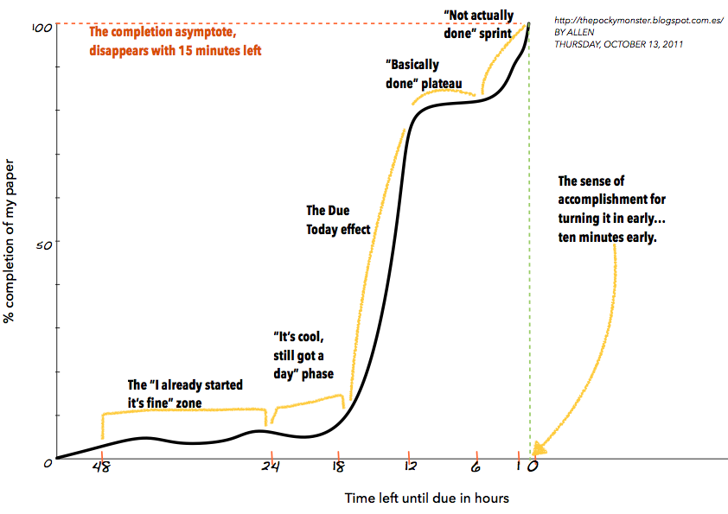
Figure 1. This is an example of a figure.

Equations
Equations should be placed on separate lines and numbered. Examples of equations are given below. Particularly,
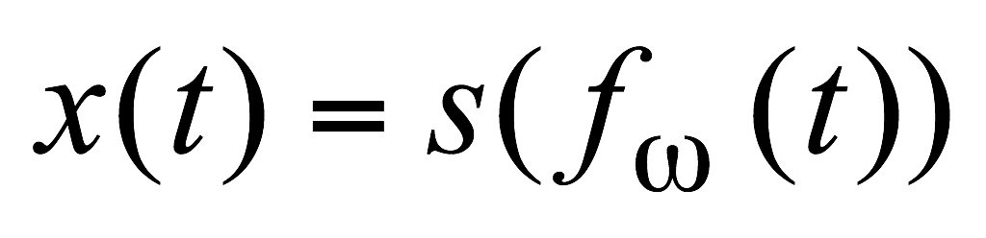 (1)
where 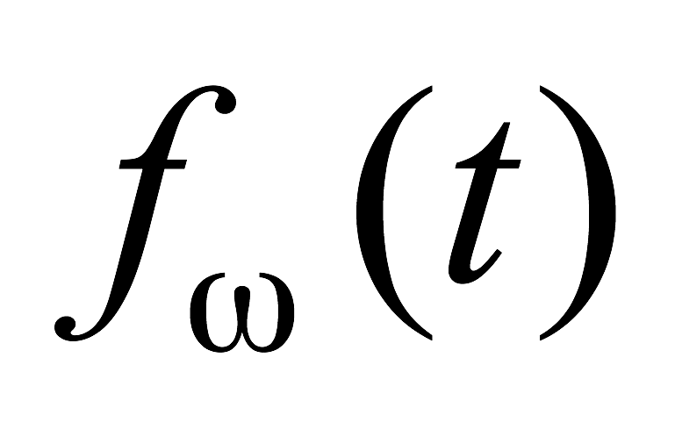 is a special warping function
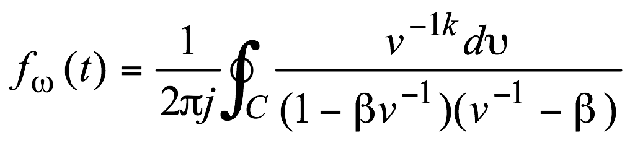 (2)
A residue theorem states that
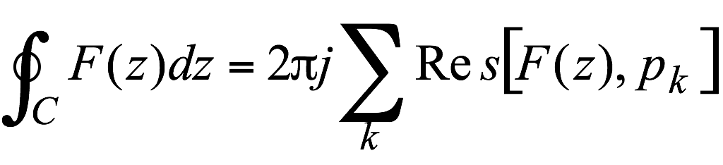 (3)
Applying theorem 3 to 1, it is quite straightforward to see that
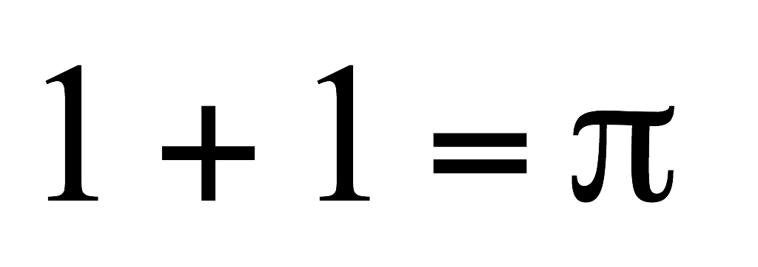 (4)
Finally we have proven the secret theorem of all speech sciences. No more math is needed to show how useful the result is!

Page numbering
Final page numbers will be added later to the document elec- tronically. Please do not include any headers or footers!

References
The reference format is the standard IEEE one. References should be numbered in order of appearance, for example [1], and later this one [2], and even later these other three [3, 4, 5].

Discussion
This is the discussion. This is the discussion. This is the dis- cussion. This is the discussion. This is the discussion. This is the discussion. This is the discussion. This is the discussion. This is the discussion. This is a boring discussion. This is the discussion. This is the discussion. This is the discussion. This is the discussion. This is the discussion.

Conclusion
This template can be found on the conference website <https://www.asvspoof.org/workshop>.

References

- Sandra M. Aluísio, Iris Barcelos, Jandir Sampaio, and Osvaldo N. Oliveira Jr, “How to learn the many unwritten ”rules of the game” of the academic discourse: a hybrid approach based on critiques and cases to support scientific writing,” in Proceedings of the IEEE International Conference on Advanced Learning Technologies, Madison, USA, August 2001, pp. 257–260.
- John Swales and Hazem Najjar, “The writing of research article introductions,” Written communication, vol. 4 no. 2, pp. 175–191, 1987.
- Robert Day and Barbara Pastel, How to write an publish a scientific paper, Cambridge University Press, 2012.
- Simone Teufel, Argumentative zoning: information extraction from scientific text, Ph.D. thesis, University of Edinburgh, 2000.
- Carol Berkenkotter, Thomas N. Huckin, and John Ackerman, “Social context and socially constructed texts: The initiation of a graduate student into a writing research community. technical report no. 33.,” Tech. Rep., Center for the Study of Writing, University of California Berkeley & Carnegie Mellon University, 1989.

